#include<string.h>

#include<stdio.h>

#include<stdlib.h>

typedef struct node

{

char ch;

int freq;

struct node \*left;

struct node \*right;

}node;

node \* heap[100];

int heapSize=0;

void Insert(node \* element)

{

heapSize++;

heap[heapSize] = element;

int now = heapSize;

while(heap[now/2] -> freq > element -> freq)

{

heap[now] = heap[now/2];

now /= 2;

}

heap[now] = element;

}

node \* DeleteMin()

{

node \* minElement,\*lastElement;

int child,now;

minElement = heap[1];

lastElement = heap[heapSize--];

for(now = 1; now\*2 <= heapSize ;now = child)

{

child = now\*2;

if(child != heapSize && heap[child+1]->freq < heap[child] -> freq )

{

child++;

}

if(lastElement -> freq > heap[child] -> freq)

{

heap[now] = heap[child];

}

else

{

break;

}

}

heap[now] = lastElement;

return minElement;

}

void print(node \*temp,char \*code)

{

if(temp->left==NULL && temp->right==NULL)

{

printf("char %c code %s\n",temp->ch,code);

return;

}

int length = strlen(code);

char leftcode[10],rightcode[10];

strcpy(leftcode,code);

strcpy(rightcode,code);

leftcode[length] = '0';

leftcode[length+1] = '\0';

rightcode[length] = '1';

rightcode[length+1] = '\0';

print(temp->left,leftcode);

print(temp->right,rightcode);

}

int main()

{

heap[0] = (node \*)malloc(sizeof(node));

heap[0]->freq = 0;

int n ;

printf("Enter the no of characters: ");

scanf("%d",&n);

printf("Enter the characters and their frequencies: ");

char ch;

int freq,i;

for(i=0;i<n;i++)

{

scanf(" %c",&ch);

scanf("%d",&freq);

node \* temp = (node \*) malloc(sizeof(node));

temp -> ch = ch;

temp -> freq = freq;

temp -> left = temp -> right = NULL;

Insert(temp);

}

if(n==1)

{

printf("char %c code 0\n",ch);

return 0;

}

for(i=0;i<n-1 ;i++)

{

node \* left = DeleteMin();

node \* right = DeleteMin();

node \* temp = (node \*) malloc(sizeof(node));

temp -> ch = 0;

temp -> left = left;

temp -> right = right;

temp -> freq = left->freq + right -> freq;

Insert(temp);

}

node \*tree = DeleteMin();

char code[10];

code[0] = '\0';

print(tree,code);

}

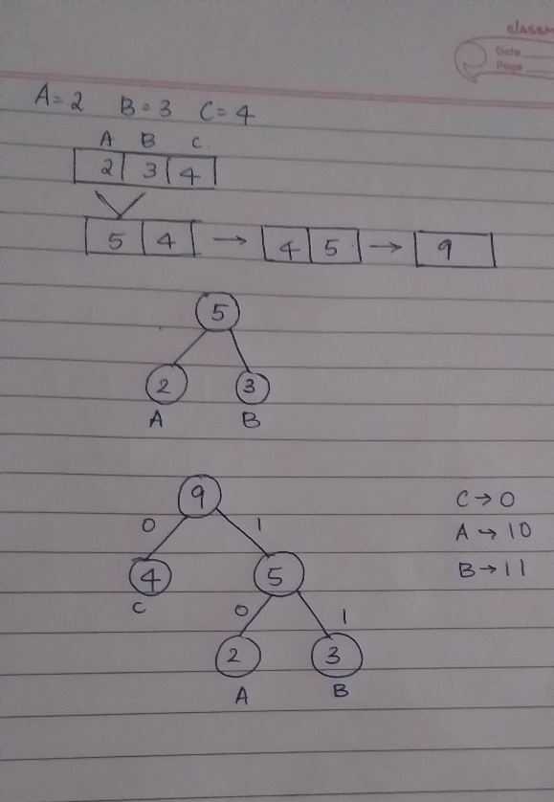

TEST CASE:

